There is a **3 lane road** of length n that consists of n + 1 **points** labeled from 0 to n. A frog **starts** at point 0 in the **second**laneand wants to jump to point n. However, there could be obstacles along the way.

You are given an array obstacles of length n + 1 where each obstacles[i] (**ranging from 0 to 3**) describes an obstacle on the lane obstacles[i] at point i. If obstacles[i] == 0, there are no obstacles at point i. There will be **at most one** obstacle in the 3 lanes at each point.

* For example, if obstacles[2] == 1, then there is an obstacle on lane 1 at point 2.

The frog can only travel from point i to point i + 1 on the same lane if there is not an obstacle on the lane at point i + 1. To avoid obstacles, the frog can also perform a **side jump** to jump to **another** lane (even if they are not adjacent) at the **same** point if there is no obstacle on the new lane.

* For example, the frog can jump from lane 3 at point 3 to lane 1 at point 3.

Return*the****minimum number of side jumps****the frog needs to reach****any lane****at point n starting from lane 2 at point 0.*

**Note:** There will be no obstacles on points 0 and n.

**Example 1:**

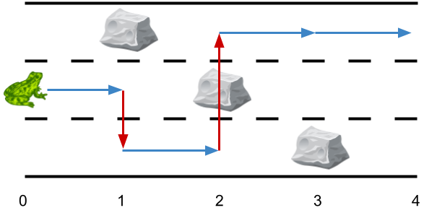

**Input:** obstacles = [0,1,2,3,0]

**Output:** 2

**Explanation:** The optimal solution is shown by the arrows above. There are 2 side jumps (red arrows).

Note that the frog can jump over obstacles only when making side jumps (as shown at point 2).

**Example 2:**

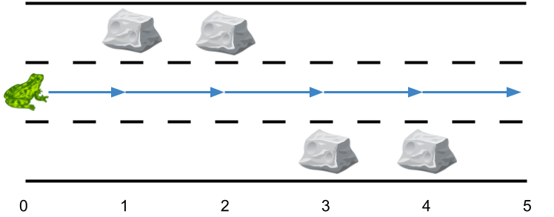

**Input:** obstacles = [0,1,1,3,3,0]

**Output:** 0

**Explanation:** There are no obstacles on lane 2. No side jumps are required.

**Example 3:**

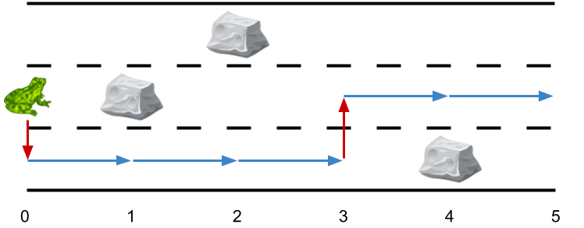

**Input:** obstacles = [0,2,1,0,3,0]

**Output:** 2

**Explanation:** The optimal solution is shown by the arrows above. There are 2 side jumps.

**Constraints:**

* obstacles.length == n + 1
* 1 <= n <= 5 * 105
* 0 <= obstacles[i] <= 3
* obstacles[0] == obstacles[n] == 0